`

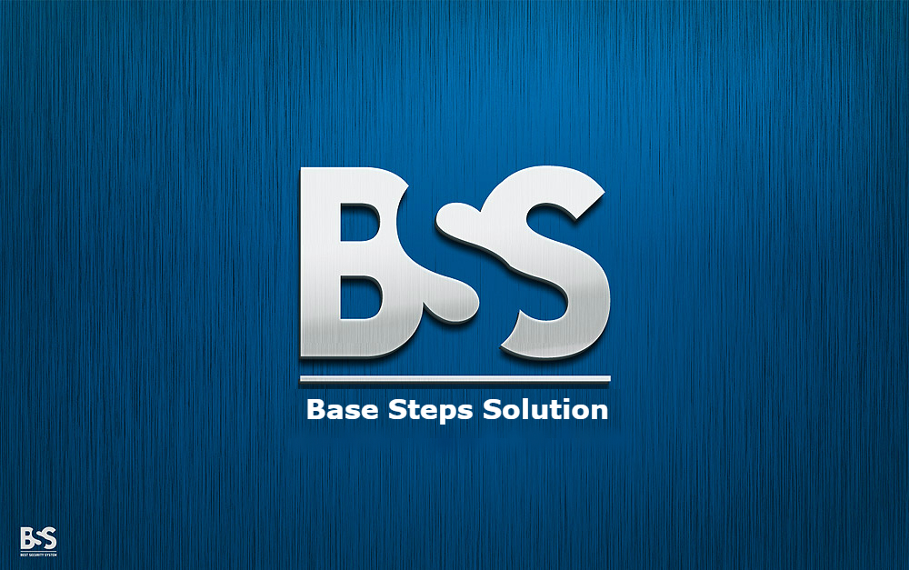

Test Plan

Van Lang Admissions

# Revision Table

|  |  |  |  |
| --- | --- | --- | --- |
| Author | Date | Reason for changes | Version |
| Nguyen Hien | 22/10/2016 | Test plan | 1.0 |
| Nguyen Hien | 1/11/2016 | Test plan | 1.1 |
| Nguyen Hien | 2/11/2016 | Test plan | 1.2 |
| Nguyen Hien | 2/11/2016 | Test plan | 1.3 |

Table of Contents

Revision Table 1

1. INTRODUCTION 3

1.1. Purpose 3

1.2. Scope 3

1.3. Objectives 3

2. Test project 4

2.1. Process flow 4

2.2. Activities 4

2.3 Roles and Responsibility 6

3. Test execution 7

3.1 Test execution process 7

3.2 Activities 9

3.3 Roles and Responsibility 9

3.4 Bugs Management 10

4. Process’s Method/Metrics 12

Track Testing’s Schedule 12

# INTRODUCTION

## Purpose

This test approach document describes the appropriate strategies, process, workflows and methodologies used to plan, organize, execute and manage testing of software projects within Van Lang Admissions.

## Scope

## The BSS Test Plan defines the unit, integration, system, regression, and Client Acceptance testing approach. The test scope includes the following:

## Testing of all functional, application performance, security and use cases requirements listed in the Use Case document.

## Quality requirements and fit metrics Van Lang Admissions.

## End-to-end testing and testing of interfaces of all systems that interact with the Van Lang Admissions.

## Objectives

* A primary objective of testing application systems is to: assure that the system meets the full requirements, including quality requirements and fit metrics for each quality requirement and satisfies the use case scenarios and maintain the quality of the product.
* The secondary objective of testing application systems will be to: identify and expose all issues and associated risks, communicate all known issues to the project team, and ensure that all issues are addressed in an appropriate matter before release. As an objective, this requires careful and methodical testing of the application to first ensure all areas of the system are scrutinized and, consequently, all issues (bugs) found are dealt with appropriately.

# Test project

## Process flow



## Activities

|  |  |  |  |  |  |
| --- | --- | --- | --- | --- | --- |
| No. | Activities | Description | Input | Output | Roles |
| 1 | Test Planning | * Analyze various testing approaches available. * Finalize on the best suited approach. * Preparation of test plan/strategy document for various types of testing. * Test tool selection. * Test effort estimation. * Resource planning and determining roles and responsibilities. | Requirement Document | Test Plan | Test Leader |
| 2 | Test case Development | * Create test cases. * Review and baseline test cases . * Create test data | Requirement Document, Test Plan | Test Cases, Test Data | Tester |
| 3 | Environment Setup | * Understand the required architecture, environment set-up. * Prepare hardware and software requirement list. * Prepare environment setup checklist. * Setup test Environment and test data | Architecture Document, | Hardware software Environment | Tester |
| 4 | Test Execution | * Execute tests as test plan. * Document test results, and log defects for failed cases. * Update test plans/test cases, if necessary. * Map defects to test cases. * Retest the defect fixes. * Track the defects to closure | Test Cases, Test Plan, Test Data, Hardware software Environment | Test Report | Tester |
| 5 | Test Closure | * Evaluate cycle completion criteria based on - Time, Test coverage , Cost , Software Quality , Critical Business Objectives. * Prepare Test closure report. * Qualitative and quantitative reporting of quality of the work product to the customer. * Test result analysis to find out the defect distribution by type and severity | Test Report | Test Closure Document | Test Leader |

## Roles and Responsibility

|  |  |
| --- | --- |
| Roles | Responsibility |
| Test Leader | To be involved in the planning, monitoring, and control of the testing activities and tasks ensure everything achieved. |
| Tester | Involved in be the primary people identifying test conditions and creating test designs, test cases, test procedure specifications and test data. |

# Test execution

## 3.1 Test execution process



## 3.2 Activities

|  |  |  |  |  |  |
| --- | --- | --- | --- | --- | --- |
| No. | Activities | Description | Input | Output | Roles |
| 1 | Execute the test case | * Execute tests as test plan. * Document test results, and log defects for failed cases. | Test plan  Test case  Test Environment | List Result of test case executed | Tester |
| 2 | Analysis | * Analysis test cases result. * Evaluate the test case | List Result of test case executed | List Metric Result | Tester |
| 3 | Fix bug | * Prepare bug | List Metric Result | Fixed bug | Coder |
| 4 | Document Test Result | * Document test results | List Result of test case executed,  List Result of test case executed, | Test Report | Tester |
| 5 | Track Defect | * Evaluate cycle completion criteria based on - Time, Test, Cost , Software | Test Report | Test Closure | Tester |

## Roles and Responsibility

|  |  |
| --- | --- |
| Roles | Responsibility |
| Tester | Involved in be the primary people identifying test conditions and creating test designs, test cases, test procedure specifications and test data. |
| Coder |  |

## 3.4 Bugs Management



# Process’s Method/Metrics

### Track Testing’s Schedule

|  |  |  |  |
| --- | --- | --- | --- |
| **Goal** | | **Questions** | **Metrics** |
| Schedule | The project schedule on time | How long project team spent this project? | Number of actual time/Number of planned time Number of actual time |
| What was the accuracy of estimating the actual value of project effort | Actual Estimation effort/Estimated project effort |
| Quality product | Increase software productivity | How effective is the inspection process? | Defect removal efficiency  Average faults detected per KLOC  Average inspection rate  Average preparation rate  Average lines of code inspected |
| Total Defect Containment Effectiveness | What is the currently known effectiveness of the defect detection process prior to release? | Number of prerelease defects/All defects |

# Incremental Release Process

# Schedule

# Step Testing

# Templates

# 